附1:
分析测试实验室低值易耗品清单
器材名称 | 型号 |  |  |  | 单价 |  |  |  |  |  |  | 总价 |  |  |  | 数量 |  | 备注
注射器 | 1ml |  |  |  |  |  |  |  |  |  |  |  |  |  |  | 100
滴管胶头 |  |  |  |  |  |  |  |  |  |  |  |  |  |  |  | 500
火柴 |  |  |  |  |  |  |  |  |  |  |  |  |  |  |  | 100盒
小砂轮 |  |  |  |  |  |  |  |  |  |  |  |  |  |  |  | 10
注射器 | 5ml |  |  |  |  |  |  |  |  |  |  |  |  |  |  | 500
试管 | 18x180mm |  |  |  |  |  |  |  |  |  |  |  |  |  |  | 700 |  | 白色玻璃
试管 | 15x100mm |  |  |  |  |  |  |  |  |  |  |  |  |  |  | 1000 |  | 白色玻璃
试管 | 15x150mm |  |  |  |  |  |  |  |  |  |  |  |  |  |  | 200 |  | 白色玻璃
橡胶塞 | 1# |  |  |  |  |  |  |  |  |  |  |  |  |  |  | 300
试管毛刷 |  |  |  |  |  |  |  |  |  |  |  |  |  |  |  | 200
不干胶标签 | 红色 |  |  |  |  |  |  |  |  |  |  |  |  |  |  | 500张
不干胶标签 | 黄色 |  |  |  |  |  |  |  |  |  |  |  |  |  |  | 500张
不干胶标签 | 绿色 |  |  |  |  |  |  |  |  |  |  |  |  |  |  | 300张
不干胶标签 | 蓝色 |  |  |  |  |  |  |  |  |  |  |  |  |  |  | 300张
医用棉签 |  |  |  |  |  |  |  |  |  |  |  |  |  |  |  | 50包 |  | 50个/包
止水夹 |  |  |  |  |  |  |  |  |  |  |  |  |  |  |  | 100
玻璃珠 | 6mm |  |  |  |  |  |  |  |  |  |  |  |  |  |  | 500 |  | 白色玻璃
玻璃棒 | Φ3-4mm |  |  |  |  |  |  |  |  |  |  |  |  |  |  | 200根 |  | 白色玻璃（长20cm）
玻璃棒 | Φ5-6mm |  |  |  |  |  |  |  |  |  |  |  |  |  |  | 200根 |  | 白色玻璃（长30cm）
橡胶塞 | 2# |  |  |  |  |  |  |  |  |  |  |  |  |  |  | 300
短颈滴管 | 8x100mm |  |  |  |  |  |  |  |  |  |  |  |  |  |  | 300 |  | 白色玻璃
橡胶塞 | 3# |  |  |  |  |  |  |  |  |  |  |  |  |  |  | 200
玻璃棒 | Φ7-8mm |  |  |  |  |  |  |  |  |  |  |  |  |  |  | 50根 |  | 白色玻璃（长30cm）
记号笔 |  |  |  |  |  |  |  |  |  |  |  |  |  |  |  | 30只 |  | 黑色
固体胶 |  |  |  |  |  |  |  |  |  |  |  |  |  |  |  | 60只
烧杯刷 |  |  |  |  |  |  |  |  |  |  |  |  |  |  |  | 100
石棉网 | 125x125mm |  |  |  |  |  |  |  |  |  |  |  |  |  |  | 60
Ph试纸 |  |  |  |  |  |  |  |  |  |  |  |  |  |  |  | 50本 |  | 测量范围1-14
淀粉-KI试纸 |  |  |  |  |  |  |  |  |  |  |  |  |  |  |  | 20本
砂布 |  |  |  |  |  |  |  |  |  |  |  |  |  |  |  | 15张
高硼硅玻璃管 | 内径5mm，长9cm |  |  |  |  |  |  |  |  |  |  |  |  |  |  | 400个 |  | 白色玻璃用于圆盘凝胶电泳（DYY-Ⅲ27A型）
玻璃板 | 60mmx90mm |  |  |  |  |  |  |  |  |  |  |  |  |  |  | 170 | 一般窗户用玻璃即可（自行切割）
橡胶塞 | 4# |  |  |  |  |  |  |  |  |  |  |  |  |  |  | 300
橡胶塞 | 5# |  |  |  |  |  |  |  |  |  |  |  |  |  |  | 500
试管夹 |  |  |  |  |  |  |  |  |  |  |  |  |  |  |  | 200 |  | 木质 长度不小于180mm，宽度20mm，厚度10mm。试管夹闭口缝不大于1mm，最大开口距不小于25mm
螺旋止水夹 |  |  |  |  |  |  |  |  |  |  |  |  |  |  |  | 50
精盐 | 500g |  |  |  |  |  |  |  |  |  |  |  |  |  |  | 20 |  | 分析纯
100℃温度计 | 标准 |  |  |  |  |  |  |  |  |  |  |  |  |  |  | 100 |  | 白色玻璃
橡胶塞 | 6# |  |  |  |  |  |  |  |  |  |  |  |  |  |  | 500
橡胶塞 | 7# |  |  |  |  |  |  |  |  |  |  |  |  |  |  | 200
橡胶手套 | 7.5# |  |  |  |  |  |  |  |  |  |  |  |  |  |  | 100副
橡胶手套 | 6.5# |  |  |  |  |  |  |  |  |  |  |  |  |  |  | 100副
石棉网 | 150x150mm |  |  |  |  |  |  |  |  |  |  |  |  |  |  | 30
醋酸铅试纸 |  |  |  |  |  |  |  |  |  |  |  |  |  |  |  | 20本
三棱针 |  |  |  |  |  |  |  |  |  |  |  |  |  |  |  | 50只
尼龙手套 |  |  |  |  |  |  |  |  |  |  |  |  |  |  |  | 40双
长针头 |  |  |  |  |  |  |  |  |  |  |  |  |  |  |  | 10盒 |  | 长15cm孔径9G
医用纱布 |  |  |  |  |  |  |  |  |  |  |  |  |  |  |  | 1卷
表面皿 | 50mm |  |  |  |  |  |  |  |  |  |  |  |  |  |  | 100 |  | 白色玻璃
碱式滴头 |  |  |  |  |  |  |  |  |  |  |  |  |  |  |  | 150 |  | 白色玻璃。与碱式滴定管配套使用
试剂瓶 | 60ml |  |  |  |  |  |  |  |  |  |  |  |  |  |  | 300 |  | 棕色玻璃
广口瓶 | 60ml |  |  |  |  |  |  |  |  |  |  |  |  |  |  | 40 |  | 棕色玻璃
试剂瓶 | 125ml |  |  |  |  |  |  |  |  |  |  |  |  |  |  | 500 |  | 棕色玻璃
试剂瓶 | 60ml |  |  |  |  |  |  |  |  |  |  |  |  |  |  | 1000 |  | 白色玻璃
塑料带柄烧杯 | 1000 |  |  |  |  |  |  |  |  |  |  |  |  |  |  | 10
大张滤纸 | 60*60cm |  |  |  |  |  |  |  |  |  |  |  |  |  |  | 1000张
移液管 | 10ml |  |  |  |  |  |  |  |  |  |  |  |  |  |  | 100 |  | 白色玻璃
长颈滴管 | 8x200mm |  |  |  |  |  |  |  |  |  |  |  |  |  |  | 600 |  | 白色玻璃
广口瓶 | 60ml |  |  |  |  |  |  |  |  |  |  |  |  |  |  | 40 |  | 白色玻璃
蒸发皿 | 直径100mm |  |  |  |  |  |  |  |  |  |  |  |  |  |  | 60 |  | 白色陶瓷
试剂瓶 | 125ml |  |  |  |  |  |  |  |  |  |  |  |  |  |  | 1000 |  | 白色玻璃
广口瓶 | 125ml |  |  |  |  |  |  |  |  |  |  |  |  |  |  | 100 |  | 棕色玻璃
吸量管 | 1ml |  |  |  |  |  |  |  |  |  |  |  |  |  |  | 500 |  | 白色玻璃
吸量管 | 2ml |  |  |  |  |  |  |  |  |  |  |  |  |  |  | 370 |  | 白色玻璃
滴瓶 | 60ml |  |  |  |  |  |  |  |  |  |  |  |  |  |  | 600 |  | 白色玻璃
锥形瓶 | 50ml |  |  |  |  |  |  |  |  |  |  |  |  |  |  | 70 |  | 白色玻璃
烧杯 | 50ml |  |  |  |  |  |  |  |  |  |  |  |  |  |  | 100 |  | 白色玻璃
广口瓶 | 125ml |  |  |  |  |  |  |  |  |  |  |  |  |  |  | 200 |  | 白色玻璃
橡胶塞 | 8# |  |  |  |  |  |  |  |  |  |  |  |  |  |  | 200
药匙 | 15cm |  |  |  |  |  |  |  |  |  |  |  |  |  |  | 30 |  | 不锈钢
石棉网 | 200x200mm |  |  |  |  |  |  |  |  |  |  |  |  |  |  | 5
铁圈 | 小号 |  |  |  |  |  |  |  |  |  |  |  |  |  |  | 50
中速层析滤纸 | 60*60cm |  |  |  |  |  |  |  |  |  |  |  |  |  |  | 30
泥三角 | 小号 |  |  |  |  |  |  |  |  |  |  |  |  |  |  | 60
瓷坩埚 | 30ml |  |  |  |  |  |  |  |  |  |  |  |  |  |  | 60
方形饭盒 | 1000ml |  |  |  |  |  |  |  |  |  |  |  |  |  |  | 50个 |  | 白色塑料
圆形饭盒 | 1000ml |  |  |  |  |  |  |  |  |  |  |  |  |  |  | 50个 |  | 白色塑料
吸量管 | 5ml |  |  |  |  |  |  |  |  |  |  |  |  |  |  | 270 |  | 白色玻璃
试剂瓶 | 250ml |  |  |  |  |  |  |  |  |  |  |  |  |  |  | 200 |  | 棕色玻璃
试剂瓶 | 250ml |  |  |  |  |  |  |  |  |  |  |  |  |  |  | 500 |  | 白色玻璃
表面皿 | 70mm |  |  |  |  |  |  |  |  |  |  |  |  |  |  | 200 |  | 白色玻璃
锥形瓶 | 100ml |  |  |  |  |  |  |  |  |  |  |  |  |  |  | 100 |  | 白色玻璃
锥形瓶 | 150ml |  |  |  |  |  |  |  |  |  |  |  |  |  |  | 100 |  | 白色玻璃
烧杯 | 100ml |  |  |  |  |  |  |  |  |  |  |  |  |  |  | 200 |  | 白色玻璃
广口瓶 | 250ml |  |  |  |  |  |  |  |  |  |  |  |  |  |  | 100 |  | 棕色玻璃
烧杯 | 150ml |  |  |  |  |  |  |  |  |  |  |  |  |  |  | 100 |  | 白色玻璃
吸量管 | 10ml |  |  |  |  |  |  |  |  |  |  |  |  |  |  | 200 |  | 白色玻璃
滴瓶 | 60ml |  |  |  |  |  |  |  |  |  |  |  |  |  |  | 200 |  | 棕色玻璃
烧杯 | 250ml |  |  |  |  |  |  |  |  |  |  |  |  |  |  | 180 |  | 白色玻璃
广口瓶 | 250ml |  |  |  |  |  |  |  |  |  |  |  |  |  |  | 150 |  | 白色玻璃
吸量管 | 0.2ml |  |  |  |  |  |  |  |  |  |  |  |  |  |  | 200 |  | 白色玻璃
吸量管 | 0.5ml |  |  |  |  |  |  |  |  |  |  |  |  |  |  | 500 |  | 白色玻璃
滴瓶 | 125ml |  |  |  |  |  |  |  |  |  |  |  |  |  |  | 300 |  | 白色玻璃
试剂瓶 | 500ml |  |  |  |  |  |  |  |  |  |  |  |  |  |  | 150 |  | 棕色玻璃
B型管 |  |  |  |  |  |  |  |  |  |  |  |  |  |  |  | 70 |  | 白色玻璃
烧瓶夹 |  |  |  |  |  |  |  |  |  |  |  |  |  |  |  | 200
洗耳球 | 中号 |  |  |  |  |  |  |  |  |  |  |  |  |  |  | 250
洗瓶 | 500ml |  |  |  |  |  |  |  |  |  |  |  |  |  |  | 100 |  | 聚乙烯
药匙 | 18cm |  |  |  |  |  |  |  |  |  |  |  |  |  |  | 30 |  | 不锈钢
药匙 | 12cm |  |  |  |  |  |  |  |  |  |  |  |  |  |  | 20 |  | 牛角
搅拌磁子 | 6*10mm椭圆 |  |  |  |  |  |  |  |  |  |  |  |  |  |  | 70个
宽透明胶带 |  |  |  |  |  |  |  |  |  |  |  |  |  |  |  | 25
量筒 | 2ml |  |  |  |  |  |  |  |  |  |  |  |  |  |  | 70 |  | 白色玻璃
滴瓶 | 125ml |  |  |  |  |  |  |  |  |  |  |  |  |  |  | 100 |  | 棕色玻璃
漏斗 | 内径80mm |  |  |  |  |  |  |  |  |  |  |  |  |  |  | 100 |  | 白色玻璃
300℃温度计 | 标准 |  |  |  |  |  |  |  |  |  |  |  |  |  |  | 100 |  | 白色玻璃
锥形瓶 | 250ml |  |  |  |  |  |  |  |  |  |  |  |  |  |  | 120 |  | 白色玻璃
试剂瓶 | 500ml |  |  |  |  |  |  |  |  |  |  |  |  |  |  | 300 |  | 白色玻璃
量筒 | 5ml |  |  |  |  |  |  |  |  |  |  |  |  |  |  | 150 |  | 白色玻璃
量筒 | 10ml |  |  |  |  |  |  |  |  |  |  |  |  |  |  | 100 |  | 白色玻璃
酒精灯 |  |  |  |  |  |  |  |  |  |  |  |  |  |  |  | 60
擦镜纸 |  |  |  |  |  |  |  |  |  |  |  |  |  |  |  | 100本
200目尼龙布 |  |  |  |  |  |  |  |  |  |  |  |  |  |  |  | 10米
加样枪头 |  |  |  |  |  |  |  |  |  |  |  |  |  |  |  | 1000个 |  | 规格与加样枪配套使用
搅拌磁子 | 8*15mm椭圆 |  |  |  |  |  |  |  |  |  |  |  |  |  |  | 40个
移液管 | 20ml |  |  |  |  |  |  |  |  |  |  |  |  |  |  | 100 |  | 白色玻璃
漏斗 | 内径100mm |  |  |  |  |  |  |  |  |  |  |  |  |  |  | 100 |  | 白色玻璃
直形干燥管 | 19口标准口径 |  |  |  |  |  |  |  |  |  |  |  |  |  |  | 60 |  | 白色玻璃
试剂瓶 | 1000ml |  |  |  |  |  |  |  |  |  |  |  |  |  |  | 4 |  | 棕色玻璃
圆底烧瓶 | 19口50ml |  |  |  |  |  |  |  |  |  |  |  |  |  |  | 70 |  | 白色玻璃
蓝色石蕊试纸 |  |  |  |  |  |  |  |  |  |  |  |  |  |  |  | 210盒
一次性口罩 |  |  |  |  |  |  |  |  |  |  |  |  |  |  |  | 5包 |  | 20个/包
研钵 | 90mm |  |  |  |  |  |  |  |  |  |  |  |  |  |  | 10 |  | 白色玻璃
薄层板 | GF254(20*80mm) |  |  |  |  |  |  |  |  |  |  |  |  |  |  | 400
圆底烧瓶 | 19口100ml |  |  |  |  |  |  |  |  |  |  |  |  |  |  | 70 |  | 白色玻璃
量筒 | 50ml |  |  |  |  |  |  |  |  |  |  |  |  |  |  | 100 |  | 白色玻璃
试剂瓶 | 1000ml |  |  |  |  |  |  |  |  |  |  |  |  |  |  | 16 |  | 白色玻璃
定性滤纸 | 7cm |  |  |  |  |  |  |  |  |  |  |  |  |  |  | 50盒
移液管 | 25ml |  |  |  |  |  |  |  |  |  |  |  |  |  |  | 100 |  | 白色玻璃
圆底烧瓶 | 19口150ml |  |  |  |  |  |  |  |  |  |  |  |  |  |  | 70 |  | 白色玻璃
淀粉 | 500g |  |  |  |  |  |  |  |  |  |  |  |  |  |  | 4 |  | 分析纯
具塞锥形瓶 | 50ml |  |  |  |  |  |  |  |  |  |  |  |  |  |  | 70 |  | 白色玻璃
烧杯 | 1000ml |  |  |  |  |  |  |  |  |  |  |  |  |  |  | 5 |  | 白色玻璃
量筒 | 100ml |  |  |  |  |  |  |  |  |  |  |  |  |  |  | 100 |  | 白色玻璃
试剂瓶刷 | 250ml |  |  |  |  |  |  |  |  |  |  |  |  |  |  | 50
一次性手套 |  |  |  |  |  |  |  |  |  |  |  |  |  |  |  | 4袋 |  | 每袋300个
玻璃比色皿 | 光镜1cm |  |  |  |  |  |  |  |  |  |  |  |  |  |  | 250 |  | 722分光光度计专用玻璃材质
抽滤瓶 | 500ml |  |  |  |  |  |  |  |  |  |  |  |  |  |  | 30 |  | 白色玻璃
容量瓶 | 50ml |  |  |  |  |  |  |  |  |  |  |  |  |  |  | 150 |  | 白色玻璃
维生素B12注射液 |  |  |  |  |  |  |  |  |  |  |  |  |  |  |  | 20盒
布氏漏斗 | 内径80mm |  |  |  |  |  |  |  |  |  |  |  |  |  |  | 30 |  | 白色陶瓷
容量瓶 | 100ml |  |  |  |  |  |  |  |  |  |  |  |  |  |  | 100 |  | 白色玻璃
试剂瓶刷 | 500ml |  |  |  |  |  |  |  |  |  |  |  |  |  |  | 50
固体石蜡 | 用于酸式定滴管润滑 |  |  |  |  |  |  |  |  |  |  |  |  |  |  | 2盒 |  | 500g
定性滤纸 | 10cm |  |  |  |  |  |  |  |  |  |  |  |  |  |  | 50盒
塑料带柄烧杯 | 2000ml |  |  |  |  |  |  |  |  |  |  |  |  |  |  | 15 |  | 白色塑料
坐标纸 | 17*25cm |  |  |  |  |  |  |  |  |  |  |  |  |  |  | 50包 |  | 100张/包
弯盘 | 深型165*80 |  |  |  |  |  |  |  |  |  |  |  |  |  |  | 26 |  | 不锈钢
玻璃管 | 4x5mm |  |  |  |  |  |  |  |  |  |  |  |  |  |  | 2kg |  | 白色玻璃（内径*外径）
灯用酒精 | 2000ml |  |  |  |  |  |  |  |  |  |  |  |  |  |  | 40桶 |  | 分析纯
碘量瓶 | 250ml |  |  |  |  |  |  |  |  |  |  |  |  |  |  | 70 |  | 白色玻璃
漏斗 | 内径150mm |  |  |  |  |  |  |  |  |  |  |  |  |  |  | 20 |  | 白色玻璃
试剂瓶 | 2500ml |  |  |  |  |  |  |  |  |  |  |  |  |  |  | 6 |  | 棕色玻璃
变色硅胶 | 蓝色 |  |  |  |  |  |  |  |  |  |  |  |  |  |  | 2kg
玻璃管 | 7x8mm |  |  |  |  |  |  |  |  |  |  |  |  |  |  | 10kg |  | 白色玻璃（内径*外径）
容量瓶 | 250ml |  |  |  |  |  |  |  |  |  |  |  |  |  |  | 70 |  | 白色玻璃
圆形标本缸 | 80*240mm |  |  |  |  |  |  |  |  |  |  |  |  |  |  | 26 |  | 白色玻璃
圆形标本缸 | 150*180mm |  |  |  |  |  |  |  |  |  |  |  |  |  |  | 26 |  | 白色玻璃
分液漏斗 | 50ml |  |  |  |  |  |  |  |  |  |  |  |  |  |  | 70 |  | 白色玻璃
FeSO₄ | 500g |  |  |  |  |  |  |  |  |  |  |  |  |  |  | 1
复方新诺明 | 100片 |  |  |  |  |  |  |  |  |  |  |  |  |  |  | 2瓶
试剂瓶 | 2500ml |  |  |  |  |  |  |  |  |  |  |  |  |  |  | 13 |  | 白色玻璃
研钵 | 120mm |  |  |  |  |  |  |  |  |  |  |  |  |  |  | 2 |  | 白色玻璃
(NH₄)₂S₂O₈ | 500g |  |  |  |  |  |  |  |  |  |  |  |  |  |  | 1
甲苯 | 500ml |  |  |  |  |  |  |  |  |  |  |  |  |  |  | 10
盐酸肾上腺素 | 1ml |  |  |  |  |  |  |  |  |  |  |  |  |  |  | 40盒
烧杯 | 2000ml |  |  |  |  |  |  |  |  |  |  |  |  |  |  | 5 |  | 白色玻璃
试剂瓶刷 | 2500ml |  |  |  |  |  |  |  |  |  |  |  |  |  |  | 20
称量纸 | 100*100mm |  |  |  |  |  |  |  |  |  |  |  |  |  |  | 10包 |  | 100张/包
曲别针 |  |  |  |  |  |  |  |  |  |  |  |  |  |  |  | 3盒 |  | 100个/盒
周转筐 |  |  |  |  |  |  |  |  |  |  |  |  |  |  |  | 30 |  |  | 白色方形410*320*225mm
匀浆器 | 10ml |  |  |  |  |  |  |  |  |  |  |  |  |  |  | 20 |  | 白色玻璃
NaAc | 500g |  |  |  |  |  |  |  |  |  |  |  |  |  |  | 4 |  | 分析纯
白氨酸 | 5g |  |  |  |  |  |  |  |  |  |  |  |  |  |  | 1瓶
谷氨酸 | 5g |  |  |  |  |  |  |  |  |  |  |  |  |  |  | 1瓶
量筒 | 250ml |  |  |  |  |  |  |  |  |  |  |  |  |  |  | 2 |  | 白色玻璃
碱式滴定管 | 50ml |  |  |  |  |  |  |  |  |  |  |  |  |  |  | 100 |  | 白色玻璃
三颈烧瓶 | 19口250ml |  |  |  |  |  |  |  |  |  |  |  |  |  |  | 60 |  | 白色玻璃
容量瓶 | 500ml |  |  |  |  |  |  |  |  |  |  |  |  |  |  | 2 |  | 白色玻璃
匀浆器 | 20ml |  |  |  |  |  |  |  |  |  |  |  |  |  |  | 20 |  | 白色玻璃
蒸馏头 | 19口14#*3 |  |  |  |  |  |  |  |  |  |  |  |  |  |  | 60 |  | 白色玻璃
直行冷凝管 | 19口标准 |  |  |  |  |  |  |  |  |  |  |  |  |  |  | 60 |  | 白色玻璃
真空接受管 | 19口标准 |  |  |  |  |  |  |  |  |  |  |  |  |  |  | 70 |  | 白色玻璃
ZnSO₄ | 500g |  |  |  |  |  |  |  |  |  |  |  |  |  |  | 1
克式蒸馏头 | 19口标准 |  |  |  |  |  |  |  |  |  |  |  |  |  |  | 60 |  | 白色玻璃
铬黑T | 25g |  |  |  |  |  |  |  |  |  |  |  |  |  |  | 6 |  | 分析纯IND
胰岛素-R | 10ml |  |  |  |  |  |  |  |  |  |  |  |  |  |  | 4
试剂瓶刷 | 5000ml |  |  |  |  |  |  |  |  |  |  |  |  |  |  | 20
橡皮筋 |  |  |  |  |  |  |  |  |  |  |  |  |  |  |  | 1包 |  | 500个/包
医用白胶布 | 26*400cm |  |  |  |  |  |  |  |  |  |  |  |  |  |  | 2筒
医用棉球 |  |  |  |  |  |  |  |  |  |  |  |  |  |  |  | 2包 |  | 大棉球500g/包
小喷壶 |  |  |  |  |  |  |  |  |  |  |  |  |  |  |  | 10个 |  | 磨砂玻璃容量30-50ml
95%乙醇 | 500ml |  |  |  |  |  |  |  |  |  |  |  |  |  |  | 25 |  | 分析纯
蔗糖 | 500g |  |  |  |  |  |  |  |  |  |  |  |  |  |  | 5
球形冷凝管 | 19口标准 |  |  |  |  |  |  |  |  |  |  |  |  |  |  | 60 |  | 白色玻璃
试剂瓶 | 5000ml |  |  |  |  |  |  |  |  |  |  |  |  |  |  | 3 |  | 棕色玻璃
试剂瓶 | 5000ml |  |  |  |  |  |  |  |  |  |  |  |  |  |  | 6 |  | 白色玻璃
恒压滴液漏斗 | 19口50ml |  |  |  |  |  |  |  |  |  |  |  |  |  |  | 60 |  | 白色玻璃
量筒 | 500ml |  |  |  |  |  |  |  |  |  |  |  |  |  |  | 40 |  | 白色玻璃
酸式滴定管 | 50ml |  |  |  |  |  |  |  |  |  |  |  |  |  |  | 100 |  | 白色玻璃
丙酮 | 500ml |  |  |  |  |  |  |  |  |  |  |  |  |  |  | 10 |  | 分析纯
托盘天平砝码 |  |  |  |  |  |  |  |  |  |  |  |  |  |  |  | 4套
酚酞 | 25g (pH indicator) |  |  |  |  |  |  |  |  |  |  |  |  |  |  | 4 |  | 分析纯
蔗糖 | 500g |  |  |  |  |  |  |  |  |  |  |  |  |  |  | 10 |  | 分析纯
重络酸钾 | 500g |  |  |  |  |  |  |  |  |  |  |  |  |  |  | 20 |  | 分析纯
Cd(NO₃)₂ | 100g |  |  |  |  |  |  |  |  |  |  |  |  |  |  | 5
氨基黑10B | 25g |  |  |  |  |  |  |  |  |  |  |  |  |  |  | 1
甘氨酸 | 100g |  |  |  |  |  |  |  |  |  |  |  |  |  |  | 3
磷酸苯二钠 | 250g |  |  |  |  |  |  |  |  |  |  |  |  |  |  | 1
MnSO₄ | 500g |  |  |  |  |  |  |  |  |  |  |  |  |  |  | 1
乙二胺四乙酸（EDTA-Na2） | 500g |  |  |  |  |  |  |  |  |  |  |  |  |  |  | 10
氢氧化钠 | 500g |  |  |  |  |  |  |  |  |  |  |  |  |  |  | 50 |  | 分析纯
碳酸钠 | 500g |  |  |  |  |  |  |  |  |  |  |  |  |  |  | 45 |  | 分析纯
无水乙醇 | 500ml |  |  |  |  |  |  |  |  |  |  |  |  |  |  | 40 |  | 分析纯
乙酸乙酯 | 500ml |  |  |  |  |  |  |  |  |  |  |  |  |  |  | 35 |  | 分析纯
葡萄糖 | 500g |  |  |  |  |  |  |  |  |  |  |  |  |  |  | 10 |  | 分析纯
氨水 | 500ml |  |  |  |  |  |  |  |  |  |  |  |  |  |  | 80 |  | 分析纯
氯化铵 | 500g |  |  |  |  |  |  |  |  |  |  |  |  |  |  | 15 |  | 分析纯
浓硝酸 | 500ml |  |  |  |  |  |  |  |  |  |  |  |  |  |  | 20 |  | 分析纯
苯酚 | 500g |  |  |  |  |  |  |  |  |  |  |  |  |  |  | 2 |  | 分析纯
冰醋酸 | 500ml |  |  |  |  |  |  |  |  |  |  |  |  |  |  | 35 |  | 分析纯
无水乙醚 | 500ml |  |  |  |  |  |  |  |  |  |  |  |  |  |  | 50 |  | 分析纯
石油醚 | 500ml |  |  |  |  |  |  |  |  |  |  |  |  |  |  | 20 |  | 分析纯
苯甲酸乙酯 | 500g |  |  |  |  |  |  |  |  |  |  |  |  |  |  | 10 |  | 分析纯
甲醇 | 500ml |  |  |  |  |  |  |  |  |  |  |  |  |  |  | 40 |  | 分析纯
硼氢化钠 | 500g |  |  |  |  |  |  |  |  |  |  |  |  |  |  | 8 |  | 分析纯
2水BaCl₂ | 500g |  |  |  |  |  |  |  |  |  |  |  |  |  |  | 6 |  | 分析纯
(NH₃)₂C₂O₄ | 500g |  |  |  |  |  |  |  |  |  |  |  |  |  |  | 5 |  | 分析纯
Pb（NO₃）₂ | 500g |  |  |  |  |  |  |  |  |  |  |  |  |  |  | 1
苯酚 | 500g |  |  |  |  |  |  |  |  |  |  |  |  |  |  | 2
硫代硫酸钠 | 500g |  |  |  |  |  |  |  |  |  |  |  |  |  |  | 5
硼酸 | 500g |  |  |  |  |  |  |  |  |  |  |  |  |  |  | 1
NaHCO₃ | 500g |  |  |  |  |  |  |  |  |  |  |  |  |  |  | 3
KOH | 500g |  |  |  |  |  |  |  |  |  |  |  |  |  |  | 1
异丙醇 | 500ml |  |  |  |  |  |  |  |  |  |  |  |  |  |  | 8
有机试管架 | 30孔 |  |  |  |  |  |  |  |  |  |  |  |  |  |  | 50
封口毛细玻璃管 | 1.0mm |  |  |  |  |  |  |  |  |  |  |  |  |  |  | 50盒 |  | 每盒100个
开口毛细玻璃管 | 1.0mm |  |  |  |  |  |  |  |  |  |  |  |  |  |  | 10盒 |  | 每盒100个
坐标纸 | 35*50cm |  |  |  |  |  |  |  |  |  |  |  |  |  |  | 1包 |  | 100张/包
长方形塑料壶 | 25kg |  |  |  |  |  |  |  |  |  |  |  |  |  |  | 10
胶柱玻璃管支架 |  |  |  |  |  |  |  |  |  |  |  |  |  |  |  | 30个
萘 | 100g |  |  |  |  |  |  |  |  |  |  |  |  |  |  | 6 |  | 分析纯
浓硫酸 | 500ml |  |  |  |  |  |  |  |  |  |  |  |  |  |  | 30 |  | 分析纯
二甲苯 | 500ml |  |  |  |  |  |  |  |  |  |  |  |  |  |  | 10 |  | 分析纯
镁试剂II | 25g |  |  |  |  |  |  |  |  |  |  |  |  |  |  | 5 |  | 分析纯
Pb(NO₃)₂ | 500g |  |  |  |  |  |  |  |  |  |  |  |  |  |  | 2 |  | 分析纯
H₂O₂ | 500ml |  |  |  |  |  |  |  |  |  |  |  |  |  |  | 3
复方苯甲酸酊 | 150ml |  |  |  |  |  |  |  |  |  |  |  |  |  |  | 10
过硫酸铵 | 500g |  |  |  |  |  |  |  |  |  |  |  |  |  |  | 1
四硼酸钠 | 500g |  |  |  |  |  |  |  |  |  |  |  |  |  |  | 1
柠檬酸 | 500g |  |  |  |  |  |  |  |  |  |  |  |  |  |  | 1
葡萄糖 | 500g |  |  |  |  |  |  |  |  |  |  |  |  |  |  | 2
无水丙酮 | 500ml |  |  |  |  |  |  |  |  |  |  |  |  |  |  | 10
容量瓶 | 2000ml |  |  |  |  |  |  |  |  |  |  |  |  |  |  | 3 |  | 白色玻璃
韦氏分馏柱 | 19口标准 |  |  |  |  |  |  |  |  |  |  |  |  |  |  | 60 |  | 白色玻璃
周转筐 |  |  |  |  |  |  |  |  |  |  |  |  |  |  |  | 30 |  | 红色650 *460*370
KCl | 500g |  |  |  |  |  |  |  |  |  |  |  |  |  |  | 2 |  | 分析纯
高锰酸钾 | 500g |  |  |  |  |  |  |  |  |  |  |  |  |  |  | 5 |  | 分析纯
量筒 | 1000ml |  |  |  |  |  |  |  |  |  |  |  |  |  |  | 2 |  | 白色玻璃
间苯二酚 | 100g |  |  |  |  |  |  |  |  |  |  |  |  |  |  | 1 |  | 分析纯
量杯 | 1000ml |  |  |  |  |  |  |  |  |  |  |  |  |  |  | 2 |  | 白色玻璃
浓盐酸 | 500ml |  |  |  |  |  |  |  |  |  |  |  |  |  |  | 60 |  | 分析纯
淀粉 | 500g |  |  |  |  |  |  |  |  |  |  |  |  |  |  | 10 |  | AR
三乙醇胺 | 500ml |  |  |  |  |  |  |  |  |  |  |  |  |  |  | 1 |  | 分析纯
水杨酸 | 250g |  |  |  |  |  |  |  |  |  |  |  |  |  |  | 35 |  | 分析纯
过硫酸铵 | 500g |  |  |  |  |  |  |  |  |  |  |  |  |  |  | 2 |  | 分析纯
正丁醇 | 500ml |  |  |  |  |  |  |  |  |  |  |  |  |  |  | 35 |  | 分析纯
金属钠 | 200g |  |  |  |  |  |  |  |  |  |  |  |  |  |  | 36 |  | 分析纯
磺胺甲恶错标准品 | 100g |  |  |  |  |  |  |  |  |  |  |  |  |  |  | 1瓶 |  | 分析纯
苯胺 | 500ml |  |  |  |  |  |  |  |  |  |  |  |  |  |  | 15 |  | 分析纯
H₂C₂O₄2H₂O | 500g |  |  |  |  |  |  |  |  |  |  |  |  |  |  | 6 |  | 分析纯
溴甲酚绿 | 10g |  |  |  |  |  |  |  |  |  |  |  |  |  |  | 3 |  | 分析纯
KMnO₄ | 500g |  |  |  |  |  |  |  |  |  |  |  |  |  |  | 1
氯仿 | 500ml |  |  |  |  |  |  |  |  |  |  |  |  |  |  | 15
亚硝酸钠 | 500g |  |  |  |  |  |  |  |  |  |  |  |  |  |  | 10
CaCl₂ | 500g |  |  |  |  |  |  |  |  |  |  |  |  |  |  | 1
鱼线 |  |  |  |  |  |  |  |  |  |  |  |  |  |  |  | 2盘 |  | 500米/盘，有韧性，白色
粗盐 | 4kg |  |  |  |  |  |  |  |  |  |  |  |  |  |  | 4 |  | 分析纯
橡胶软管 | 通径6 |  |  |  |  |  |  |  |  |  |  |  |  |  |  | 50 |  | 耐酸耐碱耐压力 工作压力60MPa 胶管内径 6mm，用于负压吸引
蒸馏水瓶 | 5000 ml |  |  |  |  |  |  |  |  |  |  |  |  |  |  | 50 |  | 白色玻璃
硅胶G | 500g |  |  |  |  |  |  |  |  |  |  |  |  |  |  | 40
试剂瓶 | 10000ml |  |  |  |  |  |  |  |  |  |  |  |  |  |  | 5 |  | 白色玻璃
Cr₂(SO₄)₃ | 500g |  |  |  |  |  |  |  |  |  |  |  |  |  |  | 1
醋酸纤维素薄膜 |  |  |  |  |  |  |  |  |  |  |  |  |  |  |  | 50盒 |  | 100张/盒
KClO₃ | 500g |  |  |  |  |  |  |  |  |  |  |  |  |  |  | 2
巴比妥 | 25g |  |  |  |  |  |  |  |  |  |  |  |  |  |  | 3
试剂瓶 | 10000ml |  |  |  |  |  |  |  |  |  |  |  |  |  |  | 2 |  | 棕色玻璃
芦丁片 | 100片 |  |  |  |  |  |  |  |  |  |  |  |  |  |  | 5
ETDA-二钠盐 | 500g |  |  |  |  |  |  |  |  |  |  |  |  |  |  | 10 |  | 分析纯
柠檬酸钠二水 | 500g |  |  |  |  |  |  |  |  |  |  |  |  |  |  | 5 |  | 分析纯
无水碳酸钾 | 500g |  |  |  |  |  |  |  |  |  |  |  |  |  |  | 20 |  | 分析纯
苯甲酸 | 1kg |  |  |  |  |  |  |  |  |  |  |  |  |  |  | 9 |  | 分析纯
MgCl₂ | 500g |  |  |  |  |  |  |  |  |  |  |  |  |  |  | 2 |  | 分析纯
Na₂S | 500g |  |  |  |  |  |  |  |  |  |  |  |  |  |  | 1
5水CuSO₄ | 500g |  |  |  |  |  |  |  |  |  |  |  |  |  |  | 3
KMnO₄ | 500g |  |  |  |  |  |  |  |  |  |  |  |  |  |  | 1
MnO₂ | 500g |  |  |  |  |  |  |  |  |  |  |  |  |  |  | 1
正庚烷 | 500ml |  |  |  |  |  |  |  |  |  |  |  |  |  |  | 10
硝酸铝9水 | 500g |  |  |  |  |  |  |  |  |  |  |  |  |  |  | 10
酒精喷灯 |  |  |  |  |  |  |  |  |  |  |  |  |  |  |  | 1 |  | 铜质
干粉灭火器 | 2Kg |  |  |  |  |  |  |  |  |  |  |  |  |  |  | 5个
镁屑 | 500g |  |  |  |  |  |  |  |  |  |  |  |  |  |  | 1 |  | 分析纯
量筒 | 2000ml |  |  |  |  |  |  |  |  |  |  |  |  |  |  | 3 |  | 白色玻璃
锌粒 | 500g |  |  |  |  |  |  |  |  |  |  |  |  |  |  | 4 |  | 分析纯
K₂CrO₄ | 500g |  |  |  |  |  |  |  |  |  |  |  |  |  |  | 3 |  | 分析纯
醋酸铅乙酸铅（II），三水 | 500g |  |  |  |  |  |  |  |  |  |  |  |  |  |  | 2 |  | 分析纯
无水MgSO₄ | 500g |  |  |  |  |  |  |  |  |  |  |  |  |  |  | 25 |  | 分析纯
CCl₄ | 500ml |  |  |  |  |  |  |  |  |  |  |  |  |  |  | 5
量杯 | 2000ml |  |  |  |  |  |  |  |  |  |  |  |  |  |  | 2 |  | 白色玻璃
碘水 | 250ml |  |  |  |  |  |  |  |  |  |  |  |  |  |  | 2
Cu片 | 500g |  |  |  |  |  |  |  |  |  |  |  |  |  |  | 1
石英比色皿 | 光镜1cm |  |  |  |  |  |  |  |  |  |  |  |  |  |  | 16 |  | 紫外754分光光度计专用
EDTA | 500g |  |  |  |  |  |  |  |  |  |  |  |  |  |  | 1
KBr | 500g |  |  |  |  |  |  |  |  |  |  |  |  |  |  | 1
三氯乙酸 | 500g |  |  |  |  |  |  |  |  |  |  |  |  |  |  | 4 |  | 分析纯
樟脑 | 100g |  |  |  |  |  |  |  |  |  |  |  |  |  |  | 10 |  | 分析纯
三氯醋酸 | 500g |  |  |  |  |  |  |  |  |  |  |  |  |  |  | 10
磷酸氢二钠 | 500g |  |  |  |  |  |  |  |  |  |  |  |  |  |  | 2
K₄[Fe(CN)₆] | 500g |  |  |  |  |  |  |  |  |  |  |  |  |  |  | 1
K₃[Fe(CN)₆] | 500g |  |  |  |  |  |  |  |  |  |  |  |  |  |  | 1
羧甲基纤维素钠 | 500g |  |  |  |  |  |  |  |  |  |  |  |  |  |  | 5
醋酸镁4水 | 500g |  |  |  |  |  |  |  |  |  |  |  |  |  |  | 1
无水三氯化铁 | 500g |  |  |  |  |  |  |  |  |  |  |  |  |  |  | 10 |  | 分析纯
乙酸酐 | 500ml |  |  |  |  |  |  |  |  |  |  |  |  |  |  | 20 |  | 分析纯
硫氰化钾 | 500g |  |  |  |  |  |  |  |  |  |  |  |  |  |  | 60 |  | 分析纯
溴苯 | 500g |  |  |  |  |  |  |  |  |  |  |  |  |  |  | 5 |  | AR，bp 60-分析纯90℃
环己醇 | 500ml |  |  |  |  |  |  |  |  |  |  |  |  |  |  | 20 |  | 分析纯
氯化钙 | 500g |  |  |  |  |  |  |  |  |  |  |  |  |  |  | 3 |  | 分析纯
磷酸 | 500ml |  |  |  |  |  |  |  |  |  |  |  |  |  |  | 10 |  | 分析纯
丙烯酰胺 | 500g |  |  |  |  |  |  |  |  |  |  |  |  |  |  | 1
过氯酸 | 500ml |  |  |  |  |  |  |  |  |  |  |  |  |  |  | 2
试剂瓶 | 20000ml |  |  |  |  |  |  |  |  |  |  |  |  |  |  | 2 |  | 白色玻璃
L-精氨酸 | 100g |  |  |  |  |  |  |  |  |  |  |  |  |  |  | 1
溴酚蓝 | 25g |  |  |  |  |  |  |  |  |  |  |  |  |  |  | 1
四甲基乙二胺（TEMED） | 50ml |  |  |  |  |  |  |  |  |  |  |  |  |  |  | 8
铁氰化钾 | 500g |  |  |  |  |  |  |  |  |  |  |  |  |  |  | 1
草酸钠 | 500g |  |  |  |  |  |  |  |  |  |  |  |  |  |  | 2
硫酸铜无水 | 500g |  |  |  |  |  |  |  |  |  |  |  |  |  |  | 2 |  | 分析纯
酶酚试剂盒 |  |  |  |  |  |  |  |  |  |  |  |  |  |  |  | 50盒
容量瓶 | 5000ml |  |  |  |  |  |  |  |  |  |  |  |  |  |  | 2 |  | 白色玻璃
手动单调可调加样枪 | 250ul |  |  |  |  |  |  |  |  |  |  |  |  |  |  | 22支 |  | Freshman 规格20-200μL
Bi(NO₃)₃ | 500g |  |  |  |  |  |  |  |  |  |  |  |  |  |  | 2 |  | 分析纯
葡萄糖酸钙 | 2.5kg |  |  |  |  |  |  |  |  |  |  |  |  |  |  | 1
二苯胺 | 500g |  |  |  |  |  |  |  |  |  |  |  |  |  |  | 4 |  | 分析纯
环己烷 | 500ml |  |  |  |  |  |  |  |  |  |  |  |  |  |  | 30 |  | 分析纯
酒石酸钠 | 500g |  |  |  |  |  |  |  |  |  |  |  |  |  |  | 1
婴儿秤 |  |  |  |  |  |  |  |  |  |  |  |  |  |  |  | 4台 |  | 实验用，称量兔子体重
甲叉双丙烯酰胺 | 250g |  |  |  |  |  |  |  |  |  |  |  |  |  |  | 1
Tritonx-100 | 500ml |  |  |  |  |  |  |  |  |  |  |  |  |  |  | 2
D-果糖 | 1Kg |  |  |  |  |  |  |  |  |  |  |  |  |  |  | 2 |  | 分析纯
CuO | 500g |  |  |  |  |  |  |  |  |  |  |  |  |  |  | 5 |  | 分析纯
NH₄Ac | 500g |  |  |  |  |  |  |  |  |  |  |  |  |  |  | 3 |  | 分析纯
考马斯亮蓝G-250 | 25g |  |  |  |  |  |  |  |  |  |  |  |  |  |  | 1
双氧水 | 5L |  |  |  |  |  |  |  |  |  |  |  |  |  |  | 1 |  | 分析纯
石棉布 | 1米*1.2米 |  |  |  |  |  |  |  |  |  |  |  |  |  |  | 5块
蒸馏水 |  |  |  |  |  |  |  |  |  |  |  |  |  |  |  | 8吨
乙二胺四乙酸（EDTA）（酸性） | 250g |  |  |  |  |  |  |  |  |  |  |  |  |  |  | 1
钨酸钠2水 | 500g |  |  |  |  |  |  |  |  |  |  |  |  |  |  | 2
ZnSO₄7H₂O | 500g |  |  |  |  |  |  |  |  |  |  |  |  |  |  | 5
甲基橙 | 100g(ACS reagent) |  |  |  |  |  |  |  |  |  |  |  |  |  |  | 1 |  | 分析纯
封口膜（美国进口parafilm） |  |  |  |  |  |  |  |  |  |  |  |  |  |  |  | 1卷
甲氧苄氨嘧啶标准品 | 5 |  |  |  |  |  |  |  |  |  |  |  |  |  |  | 2瓶
巴比妥钠 | 25g |  |  |  |  |  |  |  |  |  |  |  |  |  |  | 14
维生素B12标准品 | 20mg |  |  |  |  |  |  |  |  |  |  |  |  |  |  | 8
麦芽糖 | 500g |  |  |  |  |  |  |  |  |  |  |  |  |  |  | 4 |  | 分析纯
溴水 | 500ml |  |  |  |  |  |  |  |  |  |  |  |  |  |  | 1
4-氨基安替比林 | 500g |  |  |  |  |  |  |  |  |  |  |  |  |  |  | 1
碱性磷酸酶 | 10mg |  |  |  |  |  |  |  |  |  |  |  |  |  |  | 10
三羟甲基氨基甲烷（Tris） | 1kg |  |  |  |  |  |  |  |  |  |  |  |  |  |  | 1
小牛血清 | 200ml |  |  |  |  |  |  |  |  |  |  |  |  |  |  | 5
无水硫代硫酸钠 | 1kg |  |  |  |  |  |  |  |  |  |  |  |  |  |  | 5 |  | 分析纯
碘化钾 | 500g |  |  |  |  |  |  |  |  |  |  |  |  |  |  | 6 |  | 分析纯
KI | 500g |  |  |  |  |  |  |  |  |  |  |  |  |  |  | 3 |  | 分析纯
呋喃甲醛 | 500ml |  |  |  |  |  |  |  |  |  |  |  |  |  |  | 10 |  | 分析纯
Na₂[Fe(CN)₅NO] | 500g |  |  |  |  |  |  |  |  |  |  |  |  |  |  | 1
3,5-二羟基 | 25g |  |  |  |  |  |  |  |  |  |  |  |  |  |  | 1
硝酸银 | 100g |  |  |  |  |  |  |  |  |  |  |  |  |  |  | 5 |  | 分析纯
碘 | 1kg |  |  |  |  |  |  |  |  |  |  |  |  |  |  | 1 |  | 分析纯
茚三酮 | 100g |  |  |  |  |  |  |  |  |  |  |  |  |  |  | 4 |  | 分析纯
止血胶管 | 5x7mm |  |  |  |  |  |  |  |  |  |  |  |  |  |  | 50 |  | 40米/卷
止血胶管 | 6x9mm |  |  |  |  |  |  |  |  |  |  |  |  |  |  | 50米 |  | 橡胶
黑色棉布 | 6米*1.2米 |  |  |  |  |  |  |  |  |  |  |  |  |  |  | 1块
载玻片 | 20*80mm |  |  |  |  |  |  |  |  |  |  |  |  |  |  | 200个

附2：
分析测试实验室低值耐用品清单
器材名称 | 型号 | 数量 | 单价 | 总价 | 备注
铁圈 | 大号 | 50
镊子 | 15cm | 30把 |  |  | 不锈钢,平头
滴定夹 |  | 70
三角锉 |  | 1 |  |  | 家用
双凹夹 |  | 200
手术剪刀 | 直头16cm | 30 |  |  | 不锈钢
日用剪刀 |  | 2
螺丝刀 |  | 1套
钳子 |  | 1 |  |  | 日用即可
染色缸 | 方形卧式10片装 | 50 |  |  | 90*70*50mm
橡胶塞手动打孔器 |  | 1
周转筐 |  | 30个 |  |  | 蓝色方形600*420*245mm
周转箱 |  | 10个 |  |  | 白色820*565*505mm
移液管架 |  | 100
不锈钢试管架 | 30孔 | 70
托盘天平 |  | 14 |  |  | 游码0-5g 最小刻度0.1g
铁架台 |  | 100
升降台 |  | 50
手动单调可调加样枪 | 50ul | 8支 |  |  | Freshman 规格20-200μL
真空干燥皿 | 直径300mm | 4 |  |  | 白色玻璃
高低三联水龙头 |  | 48个
高低三联水龙头 |  | 48个
高低3联水龙头 |  | 2个
储物架 | 长1.8米，宽0.6米，高2.0米，分3层，不锈钢材质 | 18个
分水器 | 19口 | 60个 |  |  | 白色玻璃

附3：
分析测试实验室固定资产清单
计算器 |  | 2 |  |  |  |  |  |  | 常规计算
不锈钢兔子固定器 |  | 16个
橡胶塞电动打孔器 |  | 1
单层小推车 |  | 1
双层小推车 |  | 3 |  |  |  |  |  |  | 不锈钢
可调玻璃仪器烘干器 | 长城科工贸bkh-c | 5 |  |  |  |  |  |  | 外壳采用优质进口不锈钢或冷轧钢板制成。 内设低噪声耐高温鼓风机、能长时间连续工作。规格30孔，温度范围：120℃，功率：800W、
定时磁力搅拌器 | 长城科工贸cl-2(250ml) | 50 |  |  |  |  |  |  | 搅拌容量:20~1000mL  搅拌转速:0~1250转/分钟  电源:220V/50Hz  具有大功率加热恒温电路, 可按需求设定, 控制搅拌时间。
超声波清洗机 | 河南郑州QT20500 | 1台
电子天平 | YP2002 | 6 |  |  |  |  |  |  | 0-200g-最小刻度10mg
紫外分析仪 | WFH-203(ZF-1) | 4
圆盘电泳槽 | DYCZ-27B型 | 12台
阿贝折光仪 | WYA | 14 |  |  |  |  |  |  | 1测量范围：折射率(nD)1.3000～1.7000  Brix 0～95.0%，2  2精度：折射率(nD)±0.0002  Brix ±0.1%  3分辨率：折射率(nD)0.001  Brix 0.1%，4尺寸：21x10x24cm温度显示范围：10-50℃
电热恒温水浴箱 | 长城科工贸Hh-s两列八孔 | 12 |  |  |  |  |  |  | 温度范围：5-100℃
平板式电泳槽 | DYCP-38B | 12台
循环水式多用真空泵 | 长城科工贸SHB-3 | 9 |  |  |  |  |  |  | 1.功率：180W,电压：220V/50Hz,  2.流量：60L/Min，扬程：8M,外表尺寸：380*280*420  3.外壳材料：工程塑料，机体材质：不锈钢  4.最大真空度：0.095-0.098Mpa，单头抽气量：14L/Min  5.抽气头数：2个，储水箱容积：15L，
制冰机 | LB90 | 1台
圆盘旋光仪 | WXG-4 | 14 |  |  |  |  |  |  | 测量范围：-180°～＋180°  最小读数值：0.05°  准确度：0.05°  灵敏度：0.05°
PH计 | MP511 | 26台
电泳仪 | DYY-2C | 12台 |  |  |  |  |  |  | 输入1500A  输出600V，100mA，60W
鼓风恒温干燥箱 | 指针101 A - 2 | 4台
光栅分光光度计 | 上海精科722G | 25 |  |  |  |  |  |  | 光学系统：CT光栅单色器，1200/mm  波长范围：320～1020nm  波长精度：±2nm  波长重复性：≤1nm  测量范围：0-100%T,-0.097-1.99A,0-1999C（0-1999F）  光度准确性：±0.5%T  光谱带宽：5nm  测量光程：100mm  杂散光：≤0.３%T （340nm处）  稳定性：≤0.004A/小时（500nm预热1小时）  显示方式：4位液晶  基本测量：T,A,C  数据输出（打印）：选配RS-232C 标准接口  光源：6V10W（进口钨灯）
上皿式电子天平 | FA2004 | 1 |  |  |  |  |  |  | 电子天平分析天平[电磁传感器]  称量： 0-200g最小刻度0.1mg;
紫外分光光度计 | 海恒平754紫外可见分光光度计 | 4 |  |  |  |  |  |  | 色器 C-T式单色器，1200线全息光栅  检测器 硅光二极管  显示器 128×64大屏幕液晶显示  光源 卤钨灯20W/12V（2000小时），氘灯（1000小时），光源切换波长可设定  带宽 4nm  波长范围 190~1100nm（步进间隔0.1nm）  波长准确度 ±1.0nm（开机自动校准）  波长重现性 0.5nm  稳定性 ±0.002A/h  杂散光 ≤0.3%T（在220、340nm处）  测定范围 T：-1.0~200.0%T，A：-0.05~3.000Abs，F：0~9999，C：0~9999  透射比准确度 ±0.5%T
顶通风系统 |  | 1个
储物柜 | 高1.8米，宽1.0米，厚0.45米 | 1个
储物柜 | 长1.2米，宽0.5米，高1.8米，分3层，木质玻璃门 | 11个
储物柜 | 长1.2米，宽0.5米，高1.8米，分3层 | 6个
实验台 | 2.5m*1.2m*0.8m，上有单层试剂架和通风系统 | 24个
实验台 | 2.5m*1.2m*0.8m，上有单层试剂架，无通风系统 | 24个
后边台 | 长7米，宽0.6米，高1.0米，柜体单双层各半 | 4个
侧边台 | 长5米，宽0.6米，高1.0米，柜体单双层各半 | 4个
后边台 | 长7米，宽0.6米，高1.0米，柜体单双层各半 | 4个
侧边台 | 长5米，宽0.6米，高1.0米，柜体单双层各半 | 4个
实验台 | 台面长6米，宽0.6米，高0.8米，不带柜体 | 5个
边台 | 台面长约15米，宽0.6米，高1.0米，柜体单双层各半 | 3面边台，  长度总计  约15米
边台 | 边台长6米，宽0.6米，高1.0米，柜体单双层各半 | 1个
试剂柜 | 长1.2米，宽0.5米，高1.8米，分3层 | 8个
凳子 |  | 144个
凳子 |  | 144个
凳子 |  | 25个
实验台 | 长3.6米，宽1.8米 | 1个

附4：
分析测试实验室部分物品样图
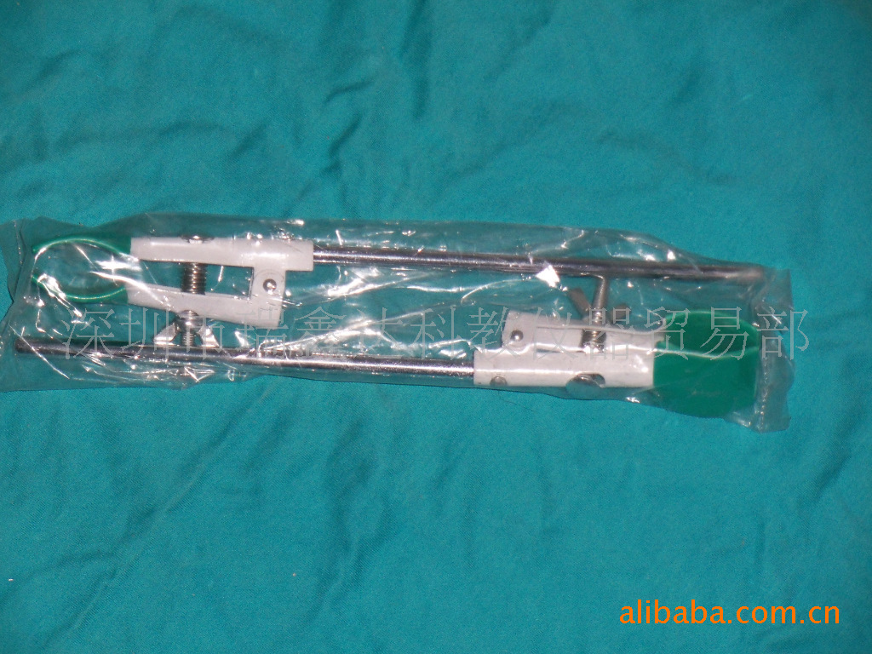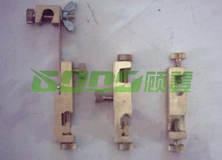
烧瓶夹 双凹夹
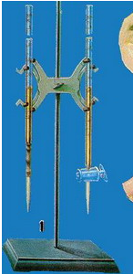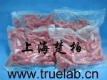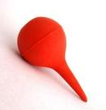
铁架台及滴定夹 滴管胶头 洗耳球
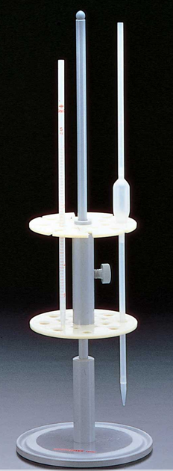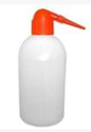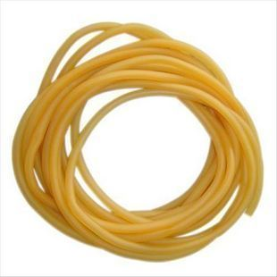
移液管架 洗瓶 止血胶管
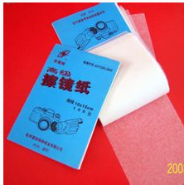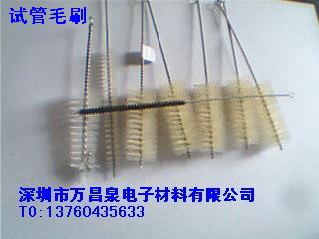
擦镜纸 试管毛刷
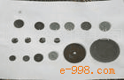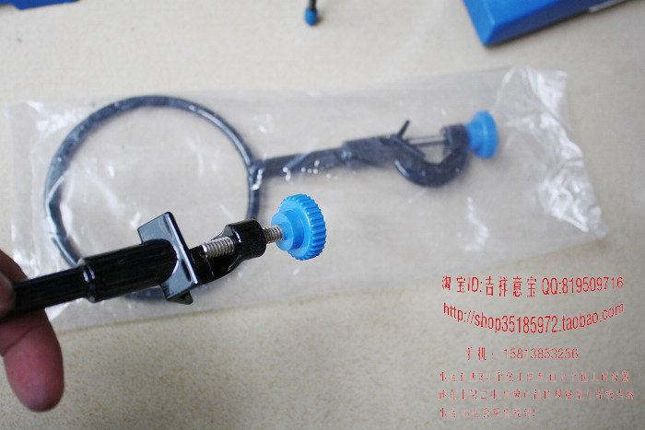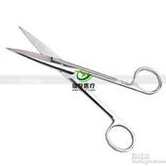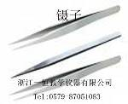
小砂轮 铁圈 手术剪刀 镊子
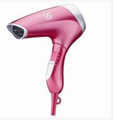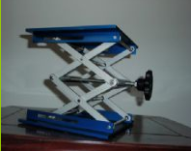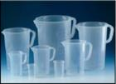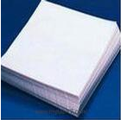
电吹风 升降台 塑料带柄烧杯 大张滤纸
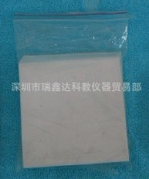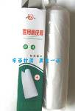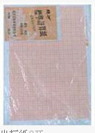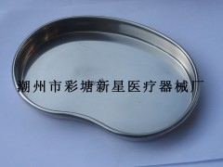
称量纸 医用白胶布 坐标纸 弯盘
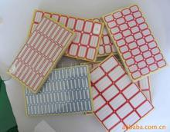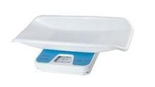
不干胶标签 婴儿秤

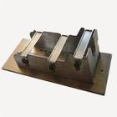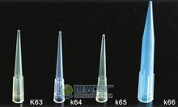
不锈钢兔子固定器 加样枪头
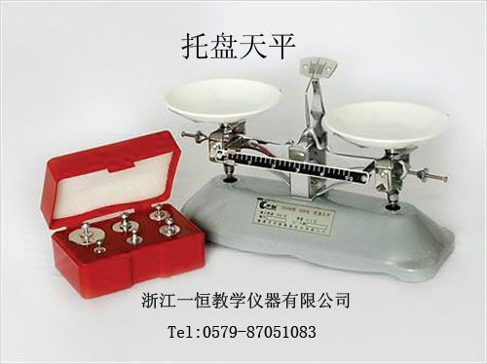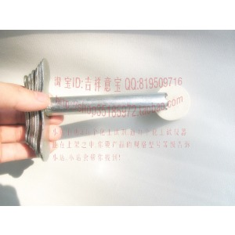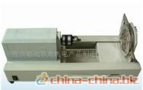
托盘天平 橡胶塞手动打孔器 橡胶塞电动打孔器
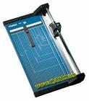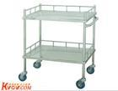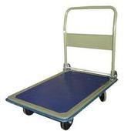
裁纸刀 双层小推车 单层小推车
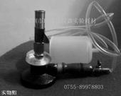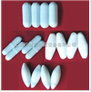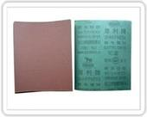
酒精喷灯 搅拌磁子 砂布
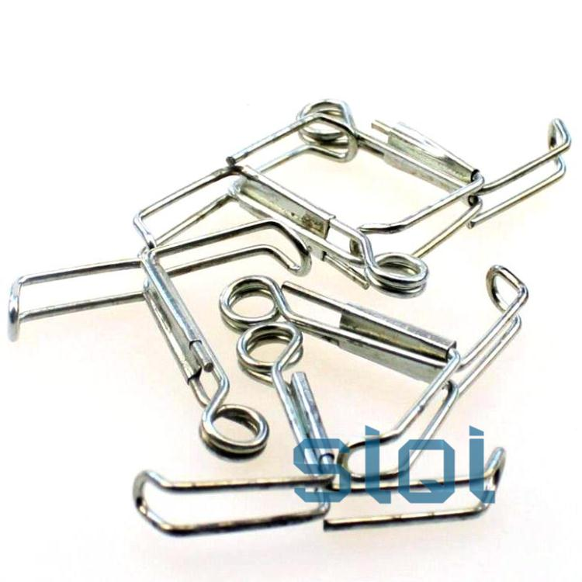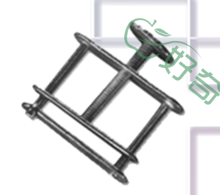
止水夹 螺旋止水夹
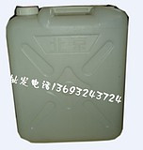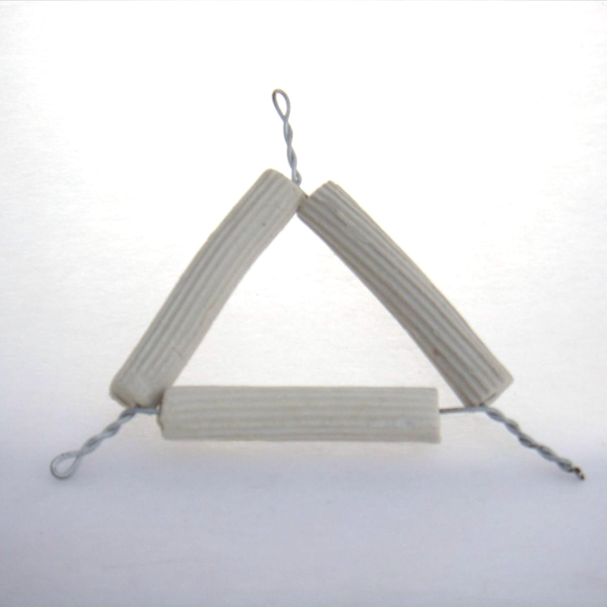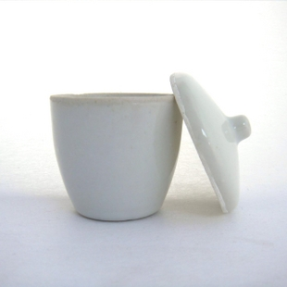
长方形塑料壶 泥三角 瓷坩埚
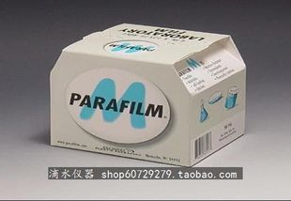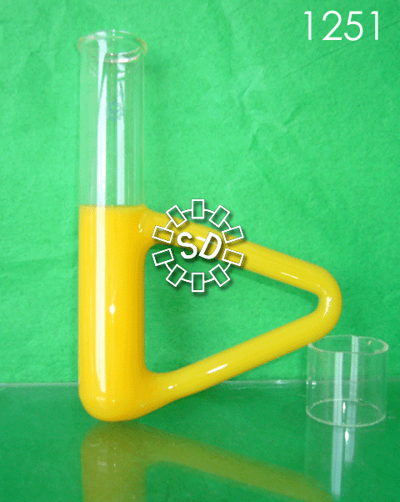
封口膜（美国进口parafilm） B型管
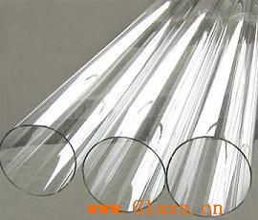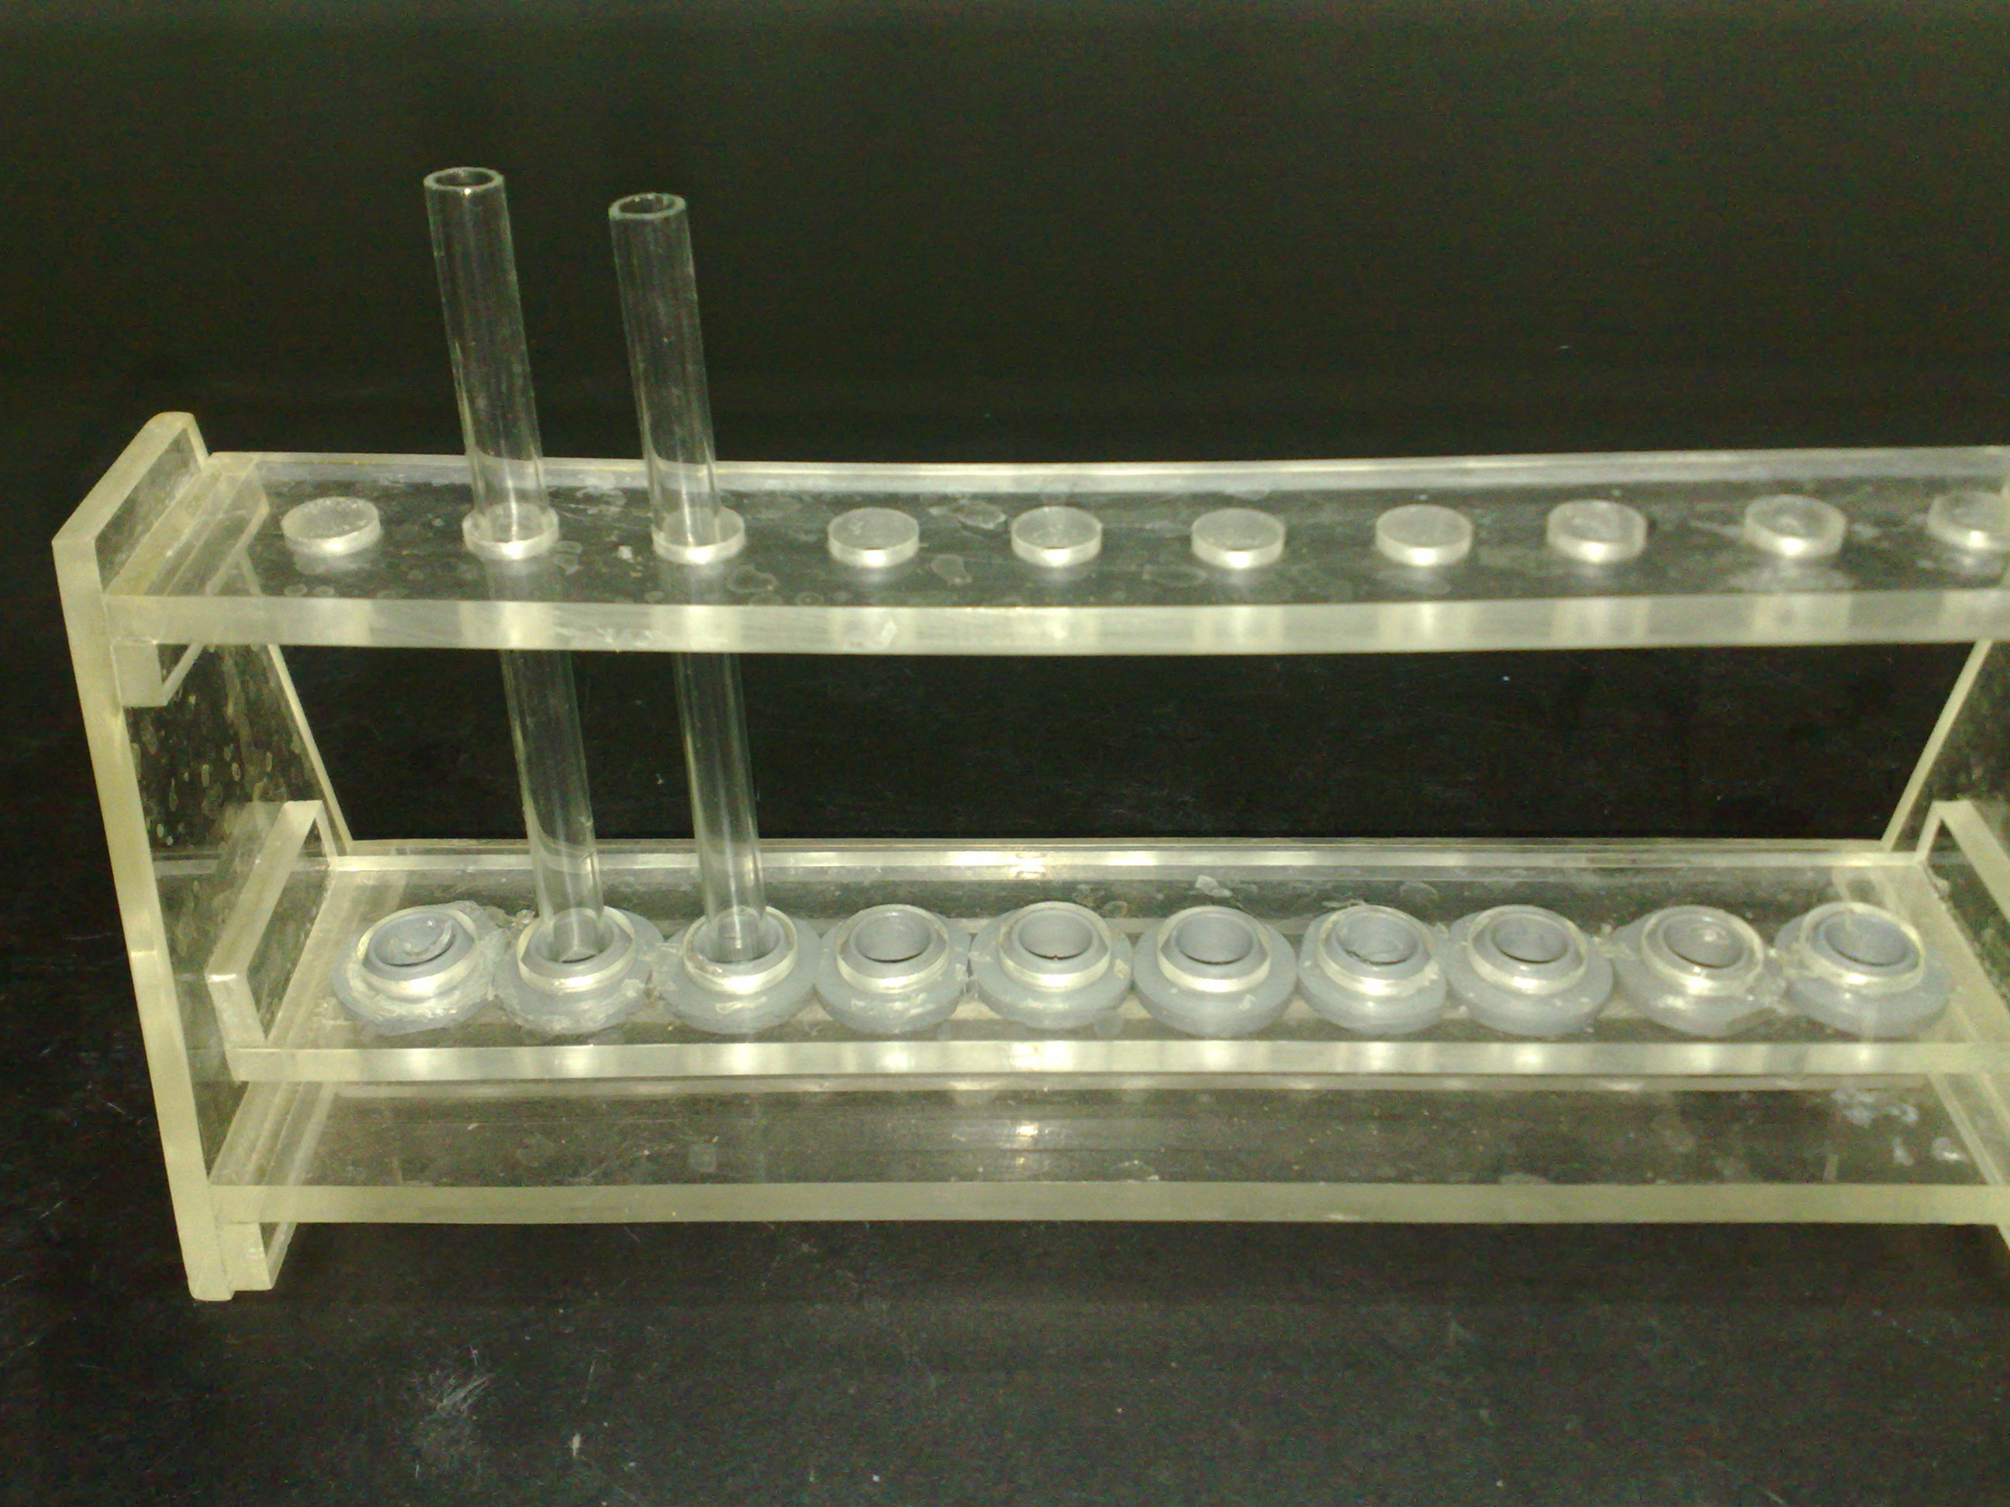
高硼硅玻璃管 胶柱玻璃管支架
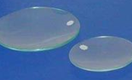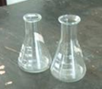
玻璃管 表面皿 锥形瓶
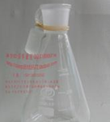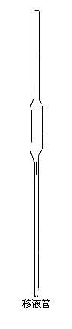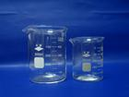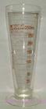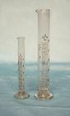
具塞锥形瓶 移液管 烧杯 量杯 量筒
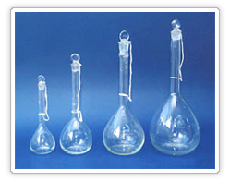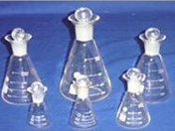
容量瓶 碘量瓶

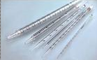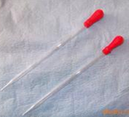
吸量管 短颈滴管
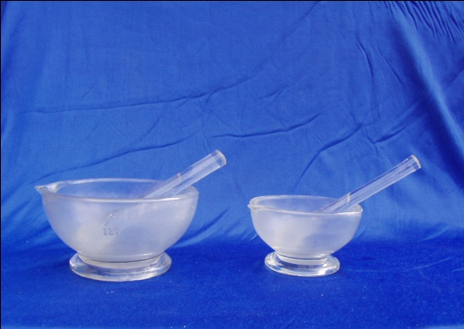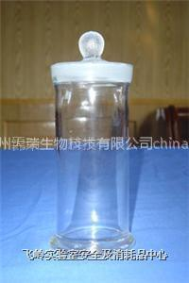
研钵 圆形标本缸
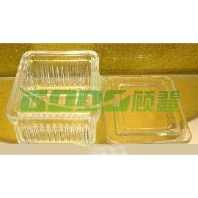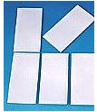
染色缸 薄层板
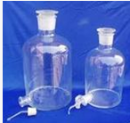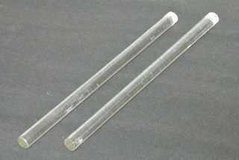
蒸馏水瓶 玻璃棒
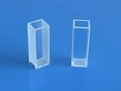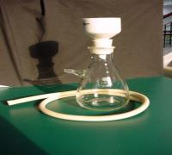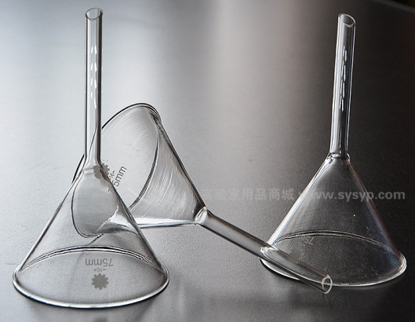
石英比色皿 抽滤瓶 漏斗
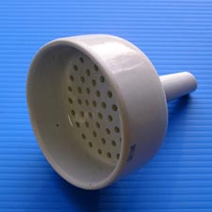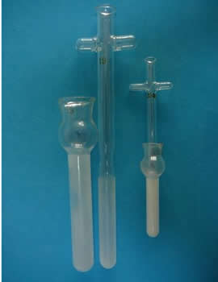
布氏漏斗 匀浆器
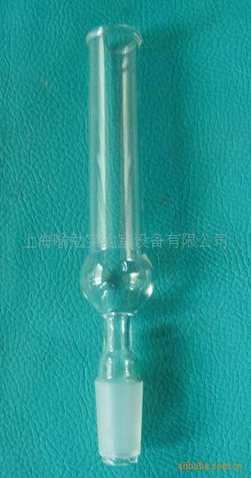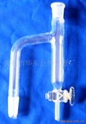
直形干燥管 分水器
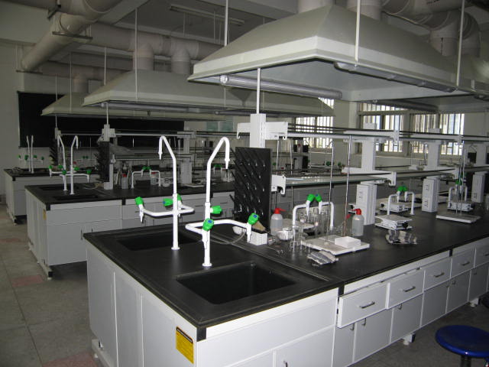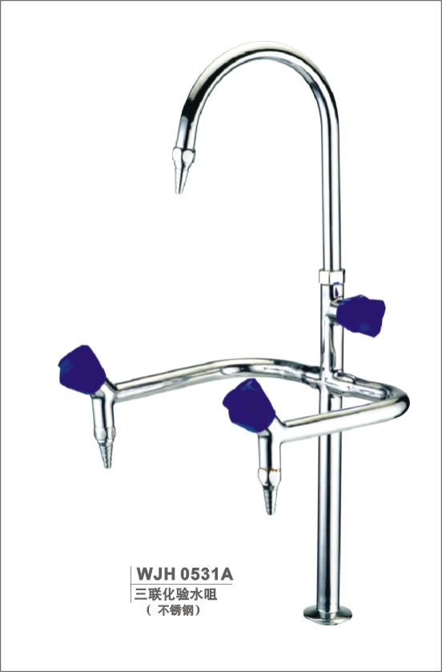
实验台 高低三联水龙头
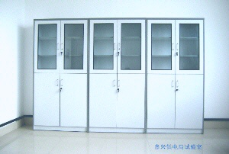
试剂室 低值耗品室
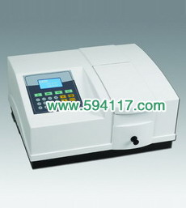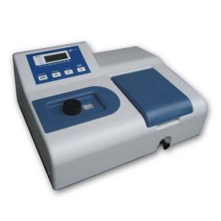
紫外分光光度计 光栅分光光度计
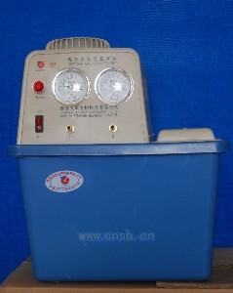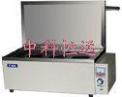
循环水式多用真空泵 电热恒温水浴箱
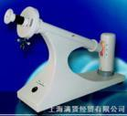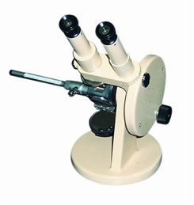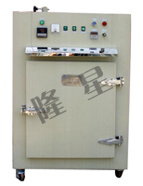
圆盘旋光仪 阿贝折光仪 鼓风恒温干燥箱
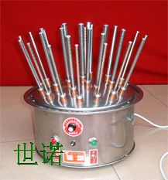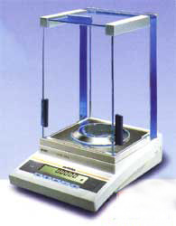
可调玻璃仪器烘干器 上皿式电子天平
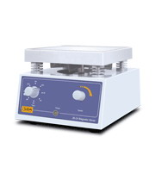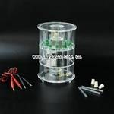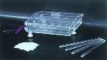
定时磁力搅拌器 圆盘电泳槽 平板式电泳槽
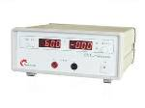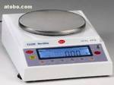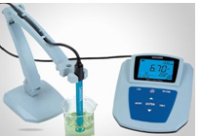
电泳仪 电子天平 PH计
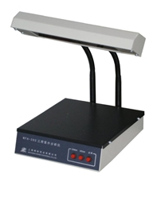
紫外分析仪

